DEFENSIVE AND COMPETITIVE BIDDING | LEADS AND SIGNALS |  |  |  |  |  |  | WBF and SBL  Convention Card |  |  | 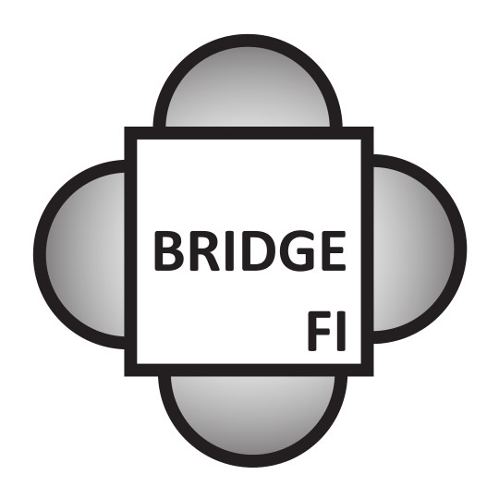
OVERCALLS (Style; Responses; 1/2 Level; Reopening) | OPENING LEADS STYLE
 |  |  | Lead |  |  | In Partner’s Suit
 | Suit
 | NT |  |  |  |  |  |  | Category:
 | Subsequent |  |  |  |  |  |  | NCBO:
 | Other : |  |  |  |  |  |  | Event:
 |  |  |  |  |  |  |  | Players:
1NT OVERCALL (2nd/4th Live; Responses; Reopening) | LEADS |  |  |  |  |  |  | SYSTEM SUMMERY
 | Lead | Vs. Suit |  |  | Vs. NT |  |  | GENERAL APPROACH AND STYLE
 | Ace
 | King
 | Queen
 | Jack
JUMP OVERCALLS (Style; Responses; Unusual NT) | 10
 | 9
 | Hi-x
 | Lo-x
 | SIGNALS IN ORDER OF PRIORITY |  |  |  |  |  |  | SPECIAL BIDS THAT MAY REQUIRE DEFENCE
DIRECT AND JUMP CUE BIDS (Style; Responses; Reopening) |  |  | Partner’s Lead | Declarer’s Lead |  |  | Discarding
 | Suit: 1st
 | 2nd
 | 3rd
VS. NT (vs. Strong/Weak; Reopening; Passed Hand) | NT: 1st
 | 2nd
 | 3rd
 | Signals (Trumps):
VS. PREEMPTS (Doubles; Cue-bids; Jumps; NT-bids) | DOUBLES |  |  |  |  |  |  | SPECIAL FORCING PASS SEQUENCES
 | TAKE-OUT DOUBLES (Style; Responses; Reopening )
VS. ARTIFICIAL STRONG OPENINGS
 | SPECIAL, ARTIFICIAL AND COMPETITIVE DOUBLES/REDOUBLES |  |  |  |  |  |  | IMPORTANT NOTES THAT DON’T FIT ELSEWHERE
OVER OPPONENTS’ TAKE-OUT DOUBLE

